Introduction to the problem:
In this model I am using a dataset with ratings of several different cereals along with various data about the cereals. I will begin by uploading the dataset to prepare it for training by normalizing the data and editing the metadata. I will use a python script to create a scatter plot of the cleansed data to see relationships between different categories. This will help me to see which features can work together in a model and which ones may not. Next, I will select the columns I want to use and split the data. Then, I will run a linear regression on the train model and score the model after that to see how close the predictions were to the actual ratings. I will add a permutation feature importance model to see which features are more important in making predictions. After, I will copy and paste the trained model to train another model with my own selected features to see the highest R² I can achieve. Finally, I will evaluate both score models to see the metrics of both models.

Uploading Dataset:
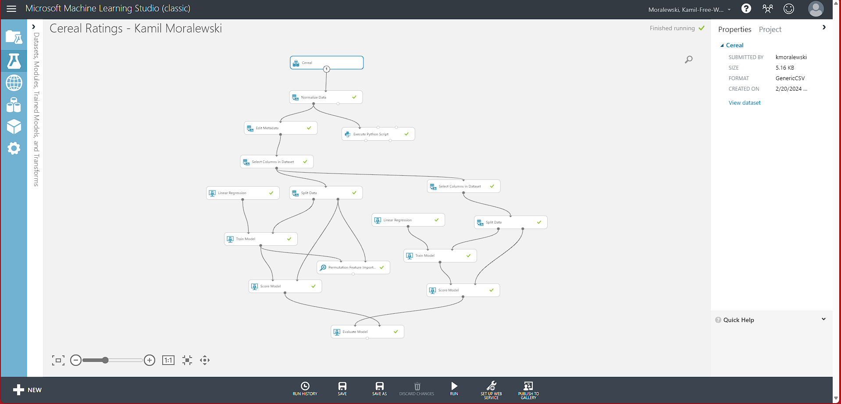

Data preparation:
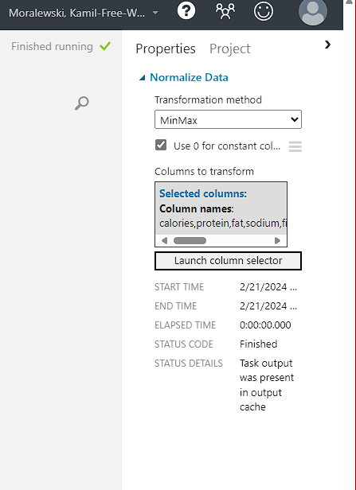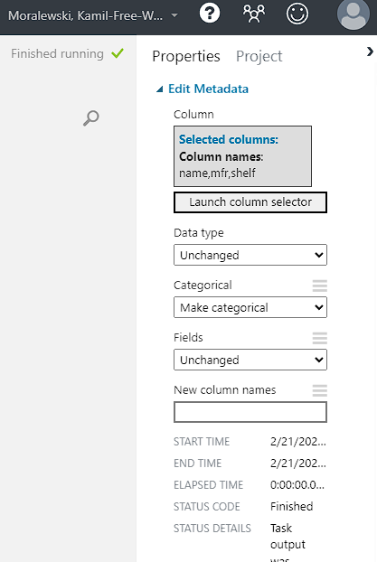

Data visualization:
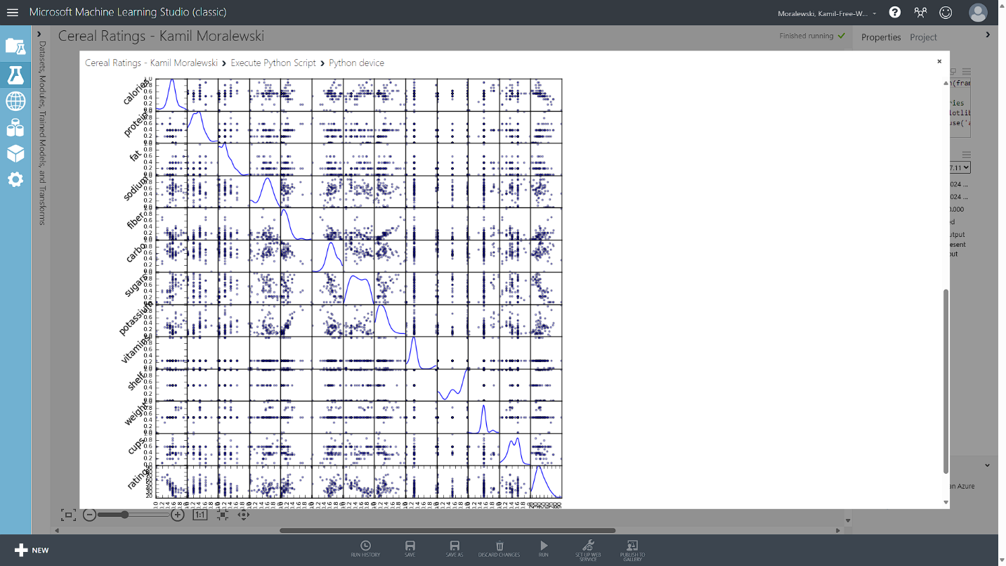

Selecting Features:
In the first select columns module, I excluded the shelf category because it did not have much variation in values on the scatter plot.
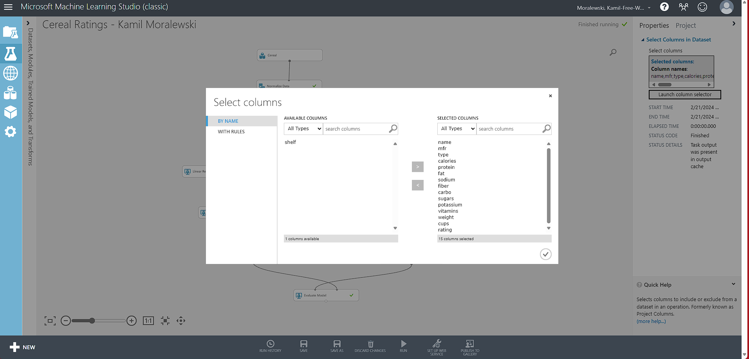
Splitting data:
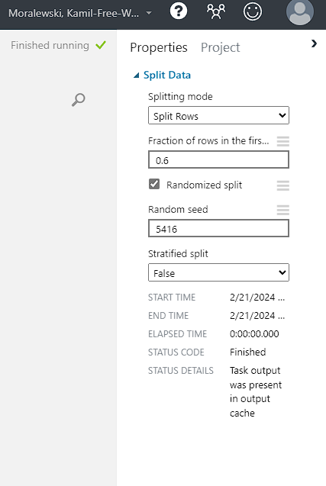
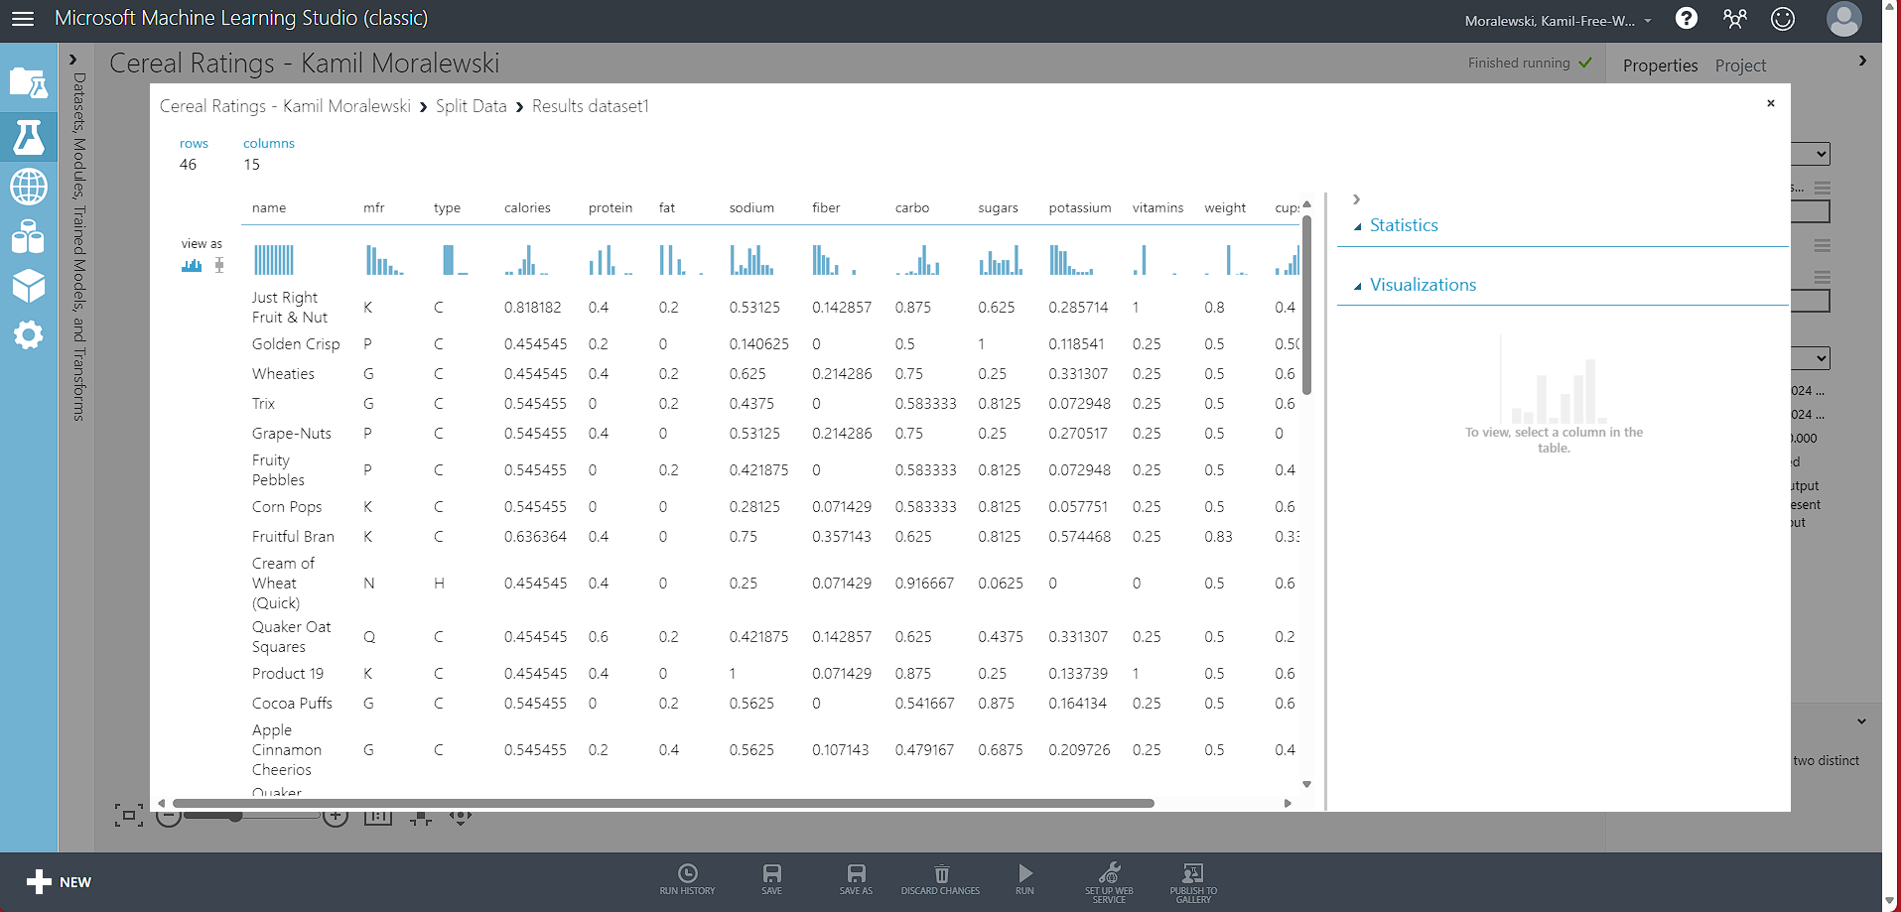
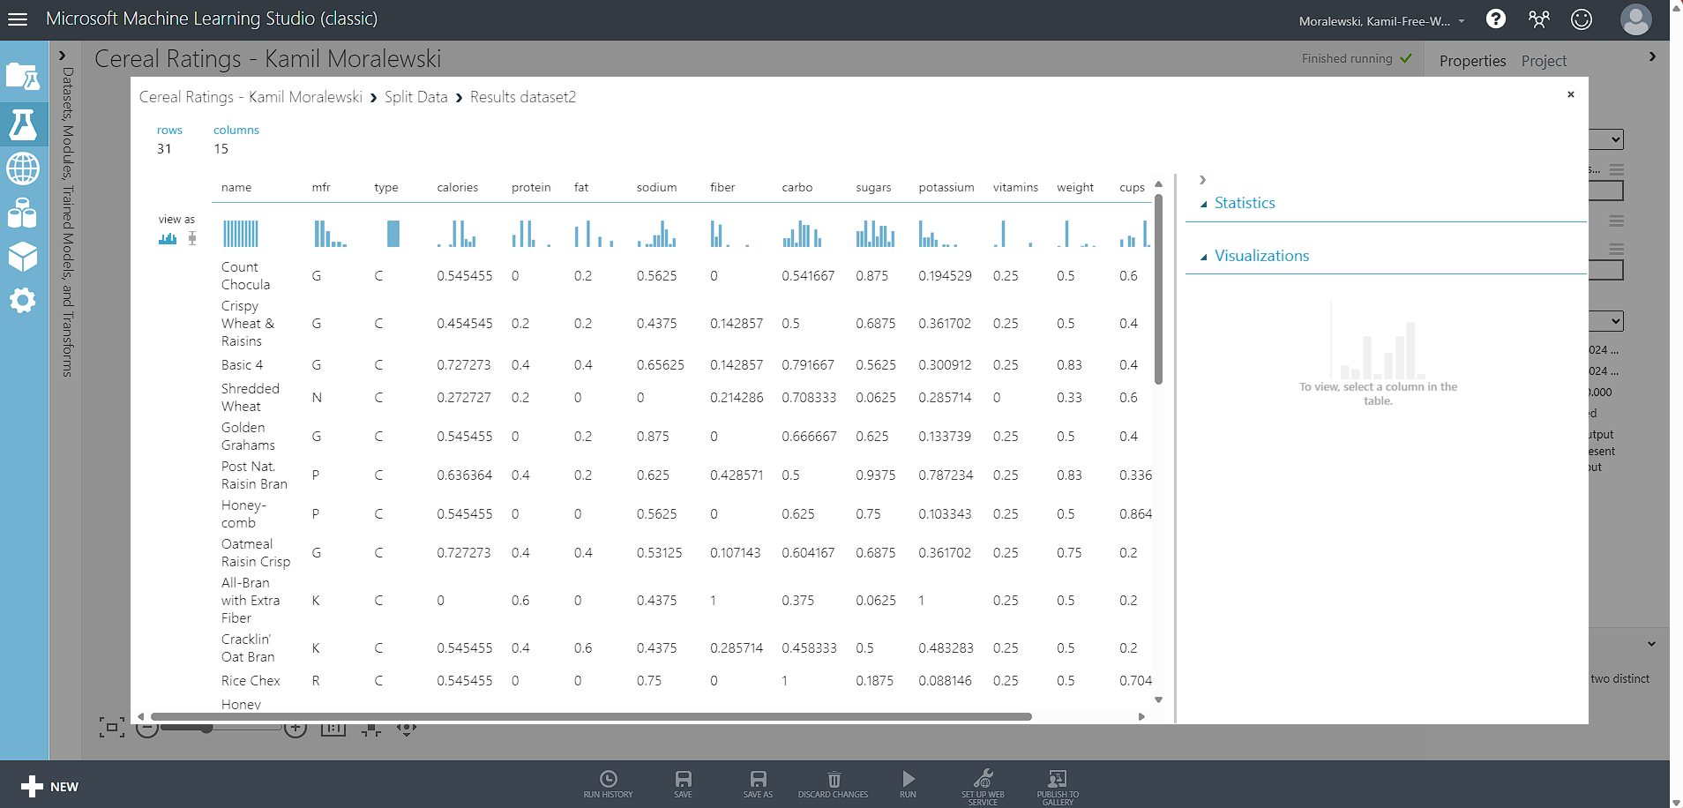

Linear Regression:
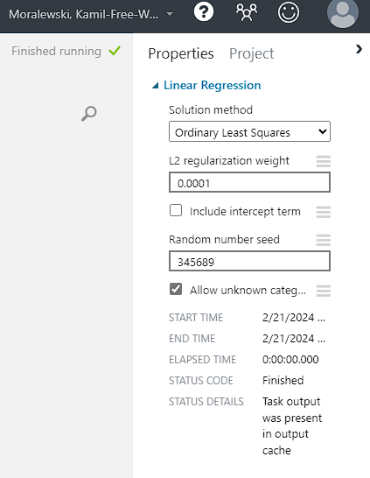
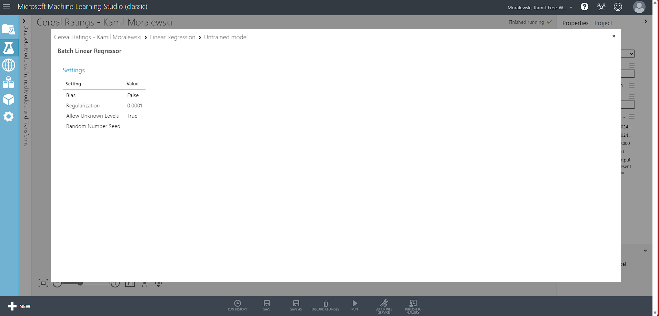

Training the model:
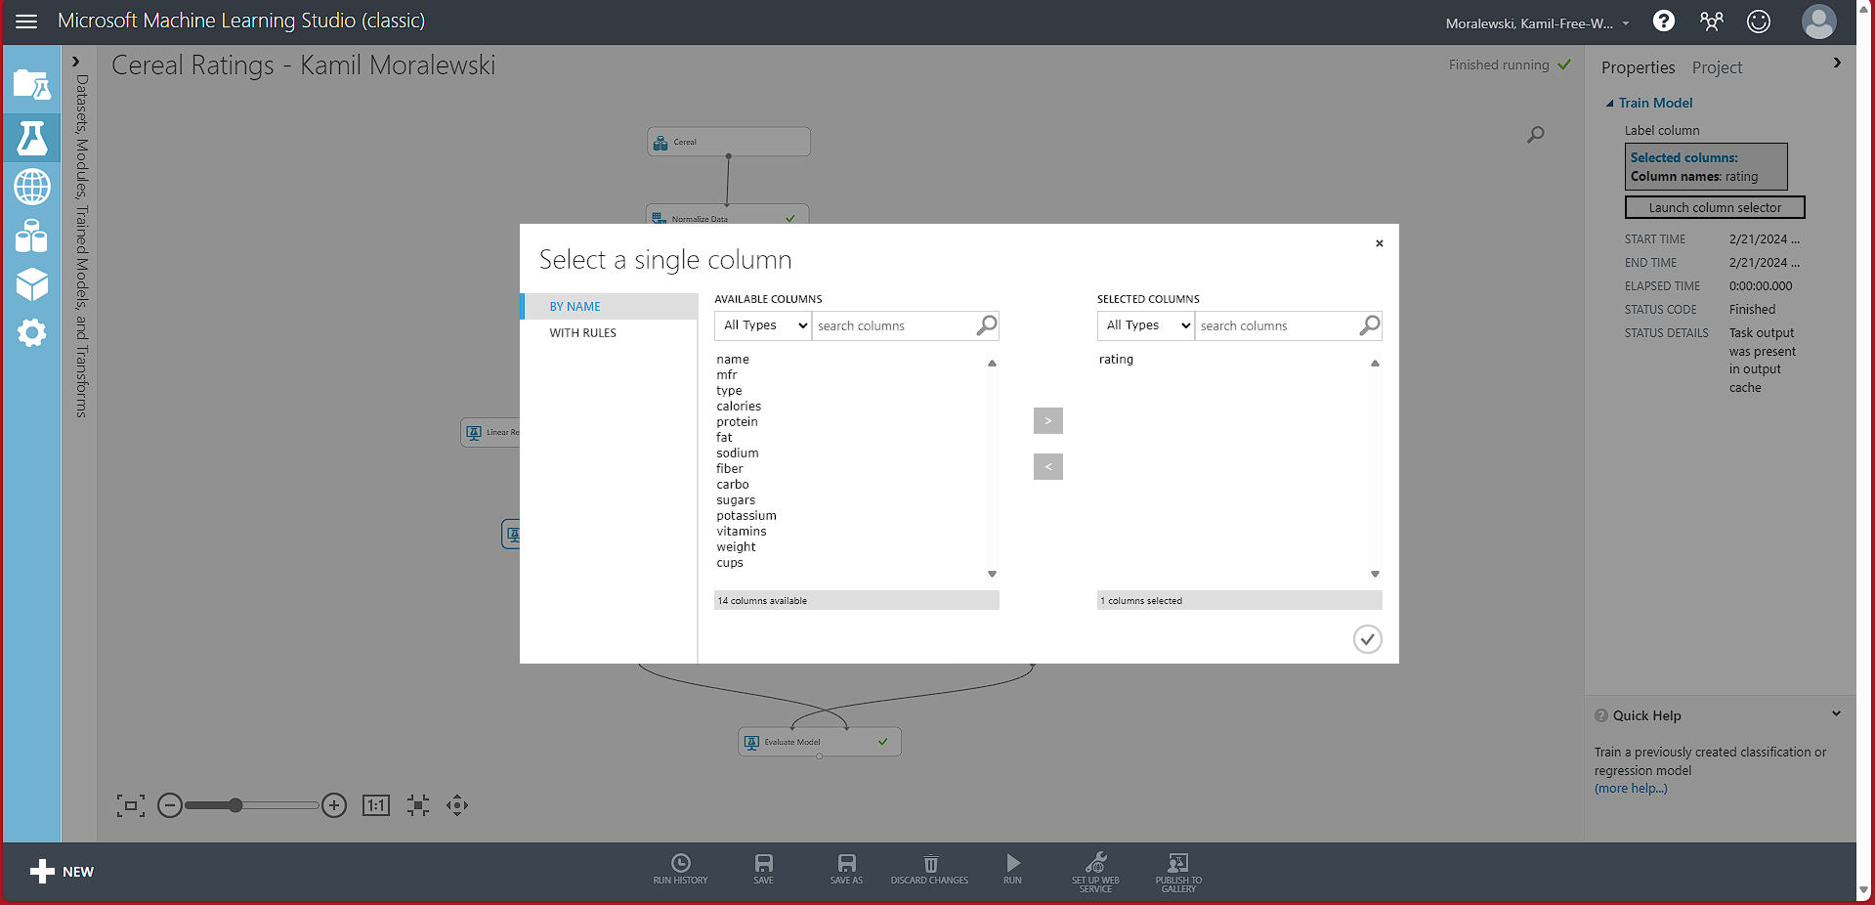
Scoring the model (show scored labels):
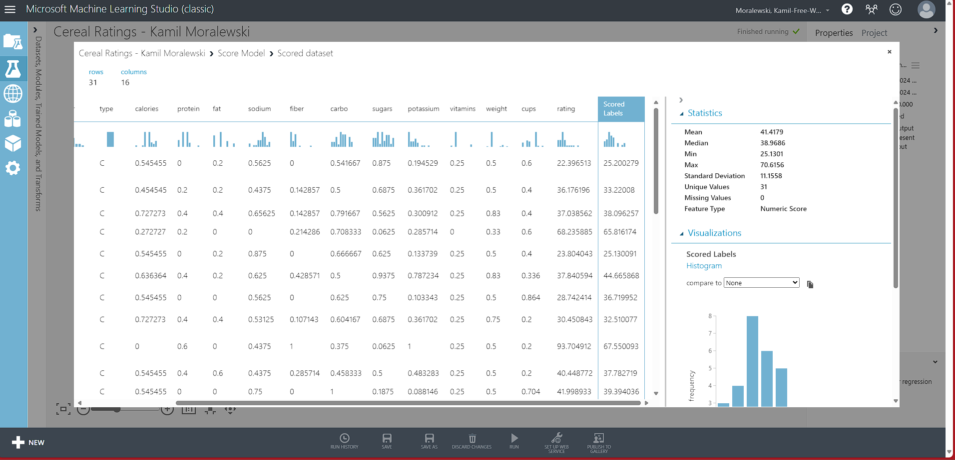

Evaluating the model:
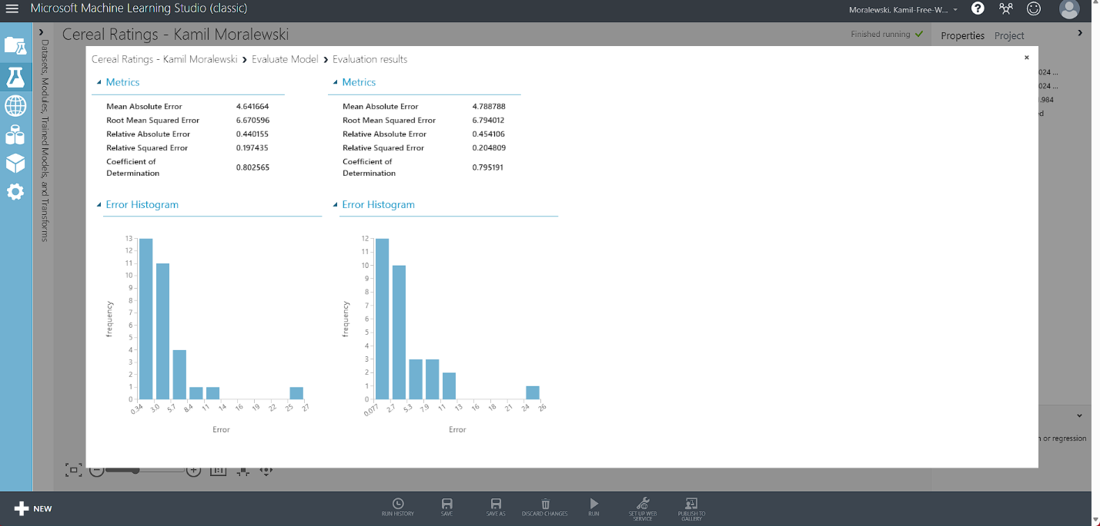

Iteration Process:
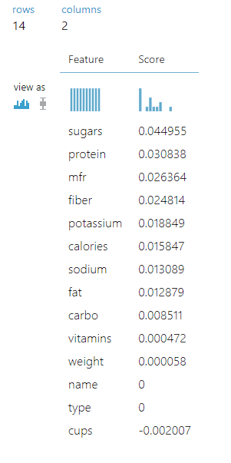
I tried a few different models with certain features unselected based on the importance of the feature noted in from the importance module. I used variations between the category’s cups, weight, vitamins, carbs, and fat. I chose them based on how low their score was in importance.
The exclusion of cups, weight, and vitamins had a value of 0.796849. The exclusion of cups, weight, vitamins, and carbo had a value of 0.773535. The exclusion of cups, weight, vitamins, and carbo had a value of 0.773535. The exclusion of cups, vitamins, and carbo had a value of 0.776666. The exclusion of cups and weights came close to the highest value at 0.802445. In the end, the cups category being excluded alone brought the largest R² value of 0.802565.
Cups had the most influence on the model and was the only feature to have a negative score in importance. Every other category had some influence on the metrics because the R² decreased with the exclusion of more categories along with cups.

Conclusion:
In conclusion, the category cups turned out to be the least influential feature in the trained model. Its exclusion made the coefficient of determination higher than the ones with other exclusions. The permutation feature importance model showed me the order of importance of all the categories where it was easy to see why cups was the least influential by being the only one with a negative score. I was able to see how each module helped in the training with the visualizations they produced.

Challenges:
- Inputting correct values for properties in each module of model
- Seeing relationships between features in the scatter plot
- Connecting correct inputs and outputs to each module

Career skills obtained:
- Preparing data for machine learning
- Evaluating classification models
- Visualizing and feature engineering data for a regression model
- Using programming languages to visualize data
- Testing and scoring a regression model
- Working with unsupervised models
- Working with recommendation models
- Publishing models to web services

Web service:
API Key:
JFfepvtY8mcmGnLhVj+eS4+Zi9FZQ1S6F4PqvIdROc/5/nHhTDK2ZG1llDrhkRvAf4UITQLgU85y+AMCG1corA==
Request URL:
https://studio.azureml.net/apihelp/workspaces/e92751accd1f4ff6941ff2f2c2a07037/webservices/9ffe41ab58504e85a4b732334fab8595/endpoints/3ceae73039ad4899a372aa4b135bd456/score

